Assignment week 13 – Rasmus Storkholm

Visualisation assignment W13

Name(s): Rasmus Storkholm

Date: Submitted March 27th 2026 (week 13), last edited 24/5/26

URL to Github code (where is your finished script):

Visualisation: (include a legible and meaningful graphic with clear labels and no scientific notation)

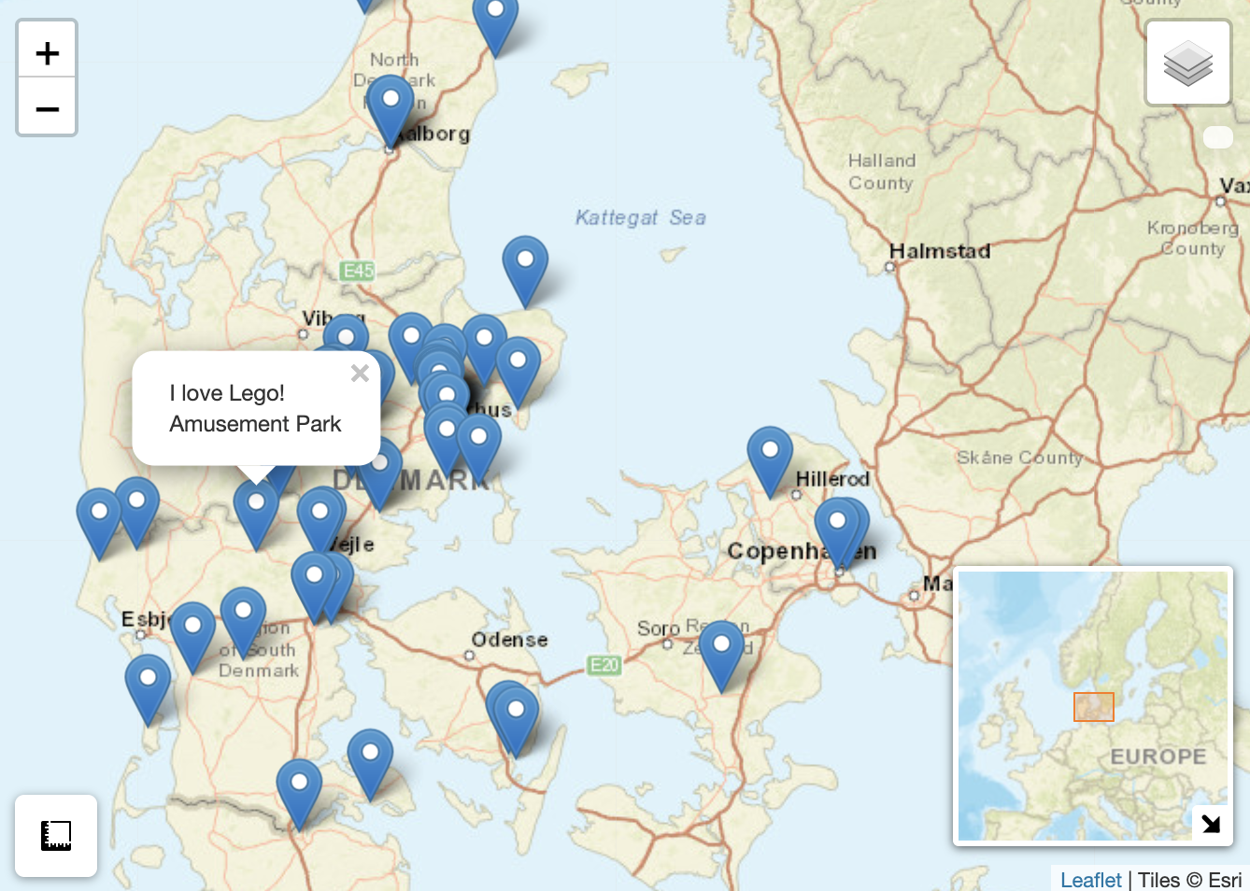
Significance: Explain what your visualisation represents and what are its implications vis-a-vis your [historical] research question (250 words)? Also, consider briefly what your visual does not show.
The visualisation is an interactive Leaflet map displaying 61 georeferenced locations across Denmark, drawn from a collaboratively compiled collaborative dataset. Each marker represents a place categorised by type, which my fellow students has chosen and is accompanied by a short description and star rating.
In relation to a historical research question concerned with the geography of cultural heritage or collective memory in Denmark, the visualisation reveals several meaningful patterns. The clustering of markers around Aarhus suggests that cultural significance, as captured here, is unevenly distributed concentrated in areas of dense population and institutional investment. Conversely, the relative sparsity of markers on Sjælland could point to either an actual scarcity of documented heritage sites or, more likely, gaps in who contributed to the dataset. The ability to toggle between clustered and individual marker views further allows the researcher to move between a macro-level reading of spatial density and a micro-level inspection of individual sites.
However, the visualisation does not show temporal change it presents all sites as existing simultaneously, with no indication of when they were built, used, or recognised as significant. It also cannot convey the qualitative depth of each site's historical meaning, nor does it account for the subjectivity inherent in the star ratings or in the selection of which places were included at all. Absences, places not mapped, remain entirely invisible.

